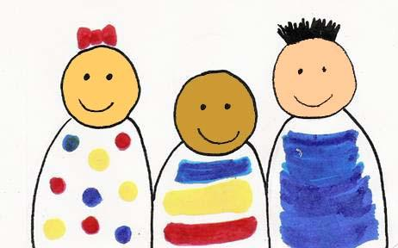
Franklin Children’s School, Inc.

School Year Calendar 2019-2020

Sunday, August 25, 2019 Ice Cream Social

Tuesday, September 3, 2019 2 Day Program Playdates and Parent Night
Wednesday, September 4, 2019 3 Day Program Playdates and Parent Night

Thursday, September 5, 2019 2 Day Programs First Day
Friday, September 6, 2019 3 Day Programs First Day

Monday, September 30, 2019 School Closed: Rosh Hashanah

Thursday, October 3, 2019 Pour Richards Meet and Greet for Parents

Wednesday, October 9, 2019 School Closed: Yom Kippur

Monday, October, 14, 2019 School Closed: Columbus Day

Sunday, October 27, 2019 Monster Bash

Monday, November, 11, 2019 School Closed: Veteran’s Day

November 27, 28, and 29, 2019 School Closed: Thanksgiving

December 19 – January 1 School Closed: Winter Vacation

Thursday, January 2, 2020 School Re-Opens for 2020

Monday, January 20, 2020 School Closed: Martin Luther King Day

February 8, 2020 Sweetheart Dance

February 17-21, 2020 School Closed: February Vacation

Tuesday, March 2020 School Closed: Professional Development Day

Friday, March 20, 2020 School Closed: Pre-K Conferences
Monday, March 23, 2020 School Closed: Pre-K Conferences

Sunday, March 29, 2020 Spring Fundraiser at Ryan Family Amusements

Friday, April 10, 2020 School Closed: Good Friday

April 20-24, 2020 School Closed: April Vacation

Monday, May 25, 2020 School Closed: Memorial Day

Monday, June 1, 2020 3 Day Programs: Last Regular Day
Tuesday, June 2, 2020 2 Day Programs: Last Regular Day

Wednesday, June 3, 2020 3 Day Program End of the Year Celebrations
Thursday, June 4, 2020 2 Day Program End of the Year Celebrations

